  
FEST Research Group

Final Year Project Proposal   
(Functional/Nonfunctional Requirements &Use Case)

|  |  |
| --- | --- |
| **Project Title:** | KIDSTUBE |
| **Degree Program/ Title:** | Computer Science |

|  |  |  |  |
| --- | --- | --- | --- |
| Project Supervisor: |  | Signature: |  |
| Project co-supervisor: |  | Signature: |  |

|  |  |  |
| --- | --- | --- |
| Student Name & Registration No: | Email & Phone Number: | Student Signature: |
| Misbah Aslam Sheikh 28272 | [misbah.asl96@gmail.com](mailto:misbah.asl96@gmail.com) 03009210111 |  |
| Muneeb Ahmed 28863 | [muneebahmed39@yahoo.com](mailto:muneebahmed39@yahoo.com) 03022220672 |  |
| Anosha Ilyas 32356 | [saadilyas49@gmail.com](mailto:saadilyas49@gmail.com) 03312087744 |  |

1. **Functional Requirements**  
   1. Sign up/Login:  
    Parent is allowed to sign up the app by entering their date of birth and email to verify the registrations.  
   2. Search Option:  
    Search option will be created in order to find the user’s desired thing.  
   3. Create Playlist:  
    Parents have the option to create playlist of their own and lock the screen so child won’t be able to search any content or video without parent’s permission.  
   4. Timeout:  
    Feature of Timeout will also be provided in order to make child not fully dependent upon the phone/ YouTube. After a certain interval of time the app will automatically close for estimated time.  
   5. Advertisement/Uploading:  
    No user is allowed to upload the video and no comments will be allowed to post, with that any sort of advertisement during the playlist or opening the app won’t be promoted either it is paid or unpaid.  
   6. Resuming:  
    When the interval of time limit finishes the app will be resumed to playlist of default page or to the parents playlist until and unless it is unlocked.
2. **Nonfunctional Requirements**  
   1. Availability:   
    This application will be available on play store and app store for users to install and use it. It should be available to use 24/7 for users (except for the time of maintenance of app).2. Modifiable:   
    This application will be modifiable according to the changing needs and requirements of potential user  
   3. Scalability:   
    This application shall be expandable to accommodate the increase in no of users.  
   4. Secure:  
    The app will be secure enough as no user is supposed any sort of this until the feature is introduced in the app.  
   5. Blocking:  
    Parent may also block the certain videos that bother them to let be watched by their child.  
   6. Performance Optimization:  
    A record of performance would be maintained that how much user is paying interest to the product by using it and refreshing the page or playing the videos.
3. **Use Case Diagram**

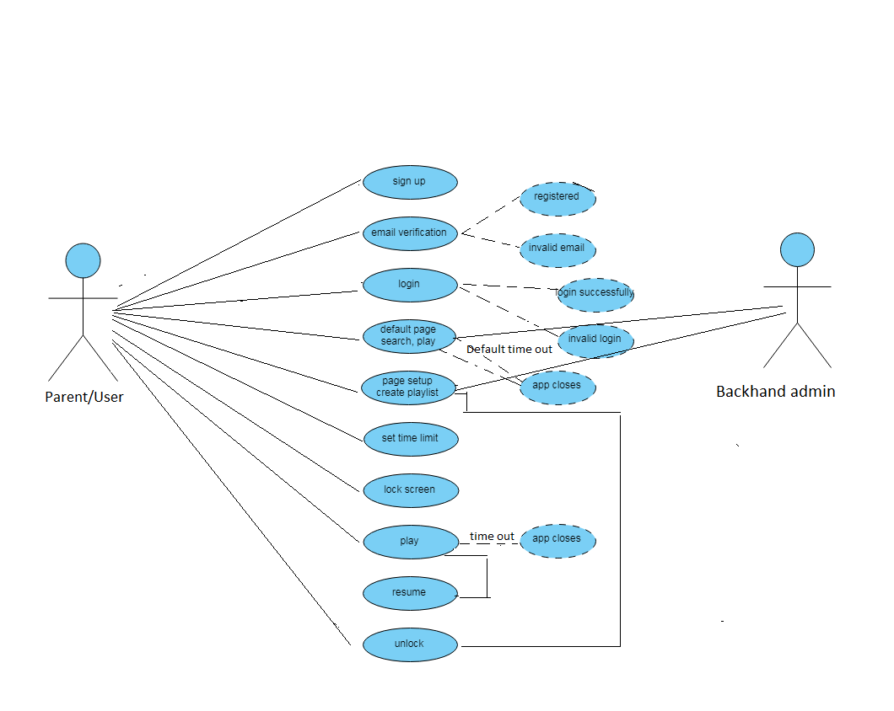

User’s aspect

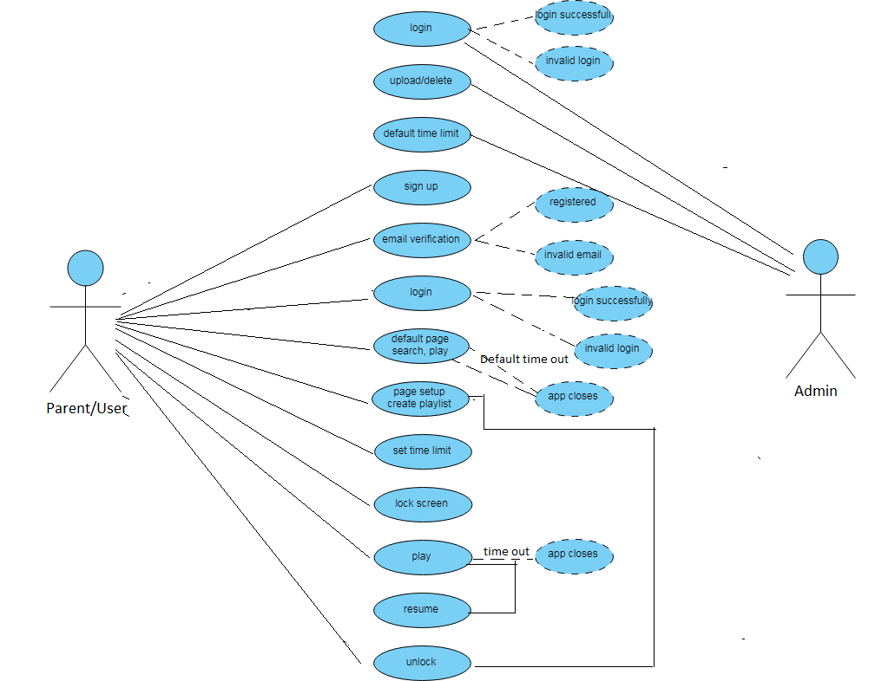

Admin’s & User’s both aspects

1. **Use Case Narratives**

|  |  |
| --- | --- |
| **Use Case Name** | Login, extends Invalid Login & Valid Login |
| **Use Case ID** | UC – 01 |
| **Actor** | Admin |
| **Description** | This use case describes the event of admin logging in to the app. |
| **Flow of Events** | 1. This use case begins when admin wants to login. 2. Prove identity through ID and Password. 3. If authentication is valid, it will go to the valid login and display the admin screen. 4. If authentication is invalid, it will go to the invalid login and display error message. |

|  |  |
| --- | --- |
| **Use Case Name** | Upload & Delete Videos |
| **Use Case ID** | UC – 02 |
| **Actor** | Admin |
| **Description** | This use case describes the event of admin uploading a new video on app and deleting a video from the app. |
| **Flow of Events** | 1. This use case begins when admin logins. 2. Admin selects the upload or delete video option. 3. If upload video option is selected, screen will be displayed where admin is prompt to upload a video with the descriptions (Optional). 4. Video will be uploaded on the application. 5. If delete video option is selected, screen will be displayed where there is list of videos and admin selects the video he wants to delete and confirm delete. 6. Video will be deleted from the application. |

|  |  |
| --- | --- |
| **Use Case Name** | Set Default Time Limit (One Time) |
| **Use Case ID** | UC – 03 |
| **Actor** | Admin |
| **Description** | This use case describes the event of admin setting default time limit. |
| **Flow of Events** | 1. This use case begins when admin logins. 2. Admin selects the set default time limit option. 3. Screen is displayed where admin is prompt to set time limit (one time) for watching certain videos. 4. Default time limit will be saved. |

|  |  |
| --- | --- |
| **Use Case Name** | Signup |
| **Use Case ID** | UC – 04 |
| **Actor** | Parent/User |
| **Description** | This use case describes the event of new user to sign up on the app. |
| **Flow of Events** | 1. This use case begins when new user wants to use the app. 2. User selects sign up option. 3. Fill up the sign up form and submit. 4. After certain verifications user will be registered. |

|  |  |
| --- | --- |
| **Use Case Name** | Email Verification extends Registered & Invalid Email |
| **Use Case ID** | UC – 05 |
| **Actor** | Parent/User |
| **Description** | This use case describes the event of verifying a new user. |
| **Flow of Events** | 1. This use case begins when new user signup's. 2. User's email address is verified by sending a verification mail. 3. If email verified, user will be registered. 4. Otherwise, user registration request will be cancelled. |

|  |  |
| --- | --- |
| **Use Case Name** | Login |
| **Use Case ID** | UC – 06 |
| **Actor** | Parent/User |
| **Description** | This use case describes the event of user logging into the app. |
| **Flow of Events** | 1. This use case begins when user wants to login 2. User prove identity through ID & Password 3. If authentication is valid, it will go to the valid login and display the admin screen. 4. If authentication is invalid, it will go to the invalid login and display error message. |

|  |  |
| --- | --- |
| **Use Case Name** | Default Page Search & Play extends App Closes |
| **Use Case ID** | UC – 07 |
| **Actor** | Parent/User |
| **Description** | This use case describes the event of screen set to default search & play |
| **Flow of Events** | 1. This use case begins when user logins. 2. User selects default search and default play. 3. Then the videos in the default will be played. 4. After the videos finish, app will close. |

|  |  |
| --- | --- |
| **Use Case Name** | Page Setup & Create Playlist |
| **Use Case ID** | UC – 08 |
| **Actor** | Parent/User |
| **Description** | This use case describes the event of user creates his own playlist and set page according to him. |
| **Flow of Events** | 1. This use case begins when user logins. 2. Selects Page setup or create playlist option. 3. Selects videos of which he wants to create playlist. 4. Playlist will be created. |

|  |  |
| --- | --- |
| **Use Case Name** | Set Time Limit |
| **Use Case ID** | UC – 09 |
| **Actor** | Parent/User |
| **Description** | This use case describes the event of user setting the time limit for their child to use the app. |
| **Flow of Events** | 1. This use case begins when user logins. 2. User selects the set time limit option. 3. Specify the duration 4. Time limit is set. |

|  |  |
| --- | --- |
| **Use Case Name** | Lock screen |
| **Use Case ID** | UC – 10 |
| **Actor** | Parent/User |
| **Description** | This use case describes the event of screen locking after the end of set time. |
| **Flow of Events** | 1. This use case begins when user is using the app. 2. User selects the option lock screen or after timeout screen will be locked automatically. 3. Screen will be disabled. |

|  |  |
| --- | --- |
| **Use Case Name** | Play Video |
| **Use Case ID** | UC – 11 |
| **Actor** | Parent/User |
| **Description** | This use case describes the event of playing a video. |
| **Flow of Events** | 1. This use case begins when user logins. 2. User select the playlist or video. 3. Video will be played. |

|  |  |
| --- | --- |
| **Use Case Name** | Resume video |
| **Use Case ID** | UC – 12 |
| **Actor** | Parent/User |
| **Description** | This use case describes the event of user resuming the video. |
| **Flow of Events** | 1. This use case begins when the app is closed or screen is locked. 2. User unlocks the screen (If locked). 3. Video or playlist will be resumed from where user paused or stopped it. |

|  |  |
| --- | --- |
| **Use Case Name** | Unlock Screen |
| **Use Case ID** | UC – 13 |
| **Actor** | Parent/User |
| **Description** | This use case describes the event of user unlocking the screen. |
| **Flow of Events** | 1. This use case begins when the app is locked & screen is disabled. 2. User enables or unlock the screen by selecting unlock or enable option. 3. Screen is unlocked. |